Arduino Lab: Instructions (with laptop)

# A few things before we start

* Let’s go over some basics to help you understand why we are connecting things the way we are.
* Circuit- electricity not only needs to get to the pieces we connect but it also needs to get back to the Arduino, without a complete “circuit” electricity cannot flow. We fix this by using negative wires to connect back to the Arduino. In this lab, black wires are used to ground the pieces and make a complete loop so everything will function correctly. Our wires will connect to the blue strip on the breadboard so we only have to connect one wire to our Arduino.
* Some of the columns are lettered differently than in our pictures. Wires and objects that are in the same row (numbered) are connected. If you are in a different column than in the pictures, don’t worry!

# Hardware: Lets connect our button

* Hardware like buttons allow us to interact with our creation. Without any input, the Arduino can only run through set programs, like blinking lights.
* Our button will require a few things.
  + The button
  + One black connector wire
  + One 10K ohm Resistor
  + 2 orange wires
* Once you have all these things, we can start connecting our Arduino to the breadboard.
* Take a look at the diagram below and the picture of the wired button. Try to recreate what you see in the pictures to connect your button.
* (**WATCH OUT** the button you will be using on your project is a little bigger than in the drawing below. It should connect to columns G and D and the rows should stay 2 and 4. This won’t affect any of the other wiring)

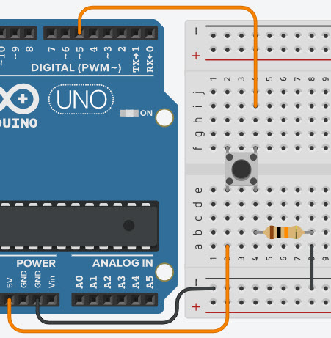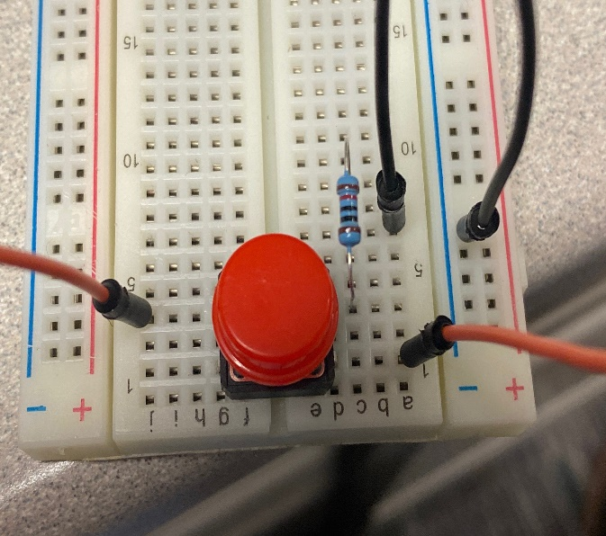

# Hardware: Add the Green Light

* Now that your button is connected, let’s start with our first light!
* Here are the components we will need to connect our first light
  + One green LED light
  + One black connector wire
  + One yellow connector wire
  + One 220 ohm resistor
* Connect the wires following this new diagram. Make sure you check over where all your wires are plugged in!
* The LED lights have a shorter and longer wire on them. The longer wire is the positive connection and you should connect it to the same row as the yellow connector wire.
* This is what your board should look like now!

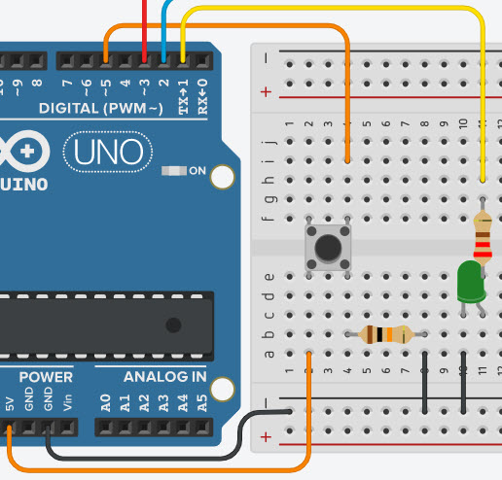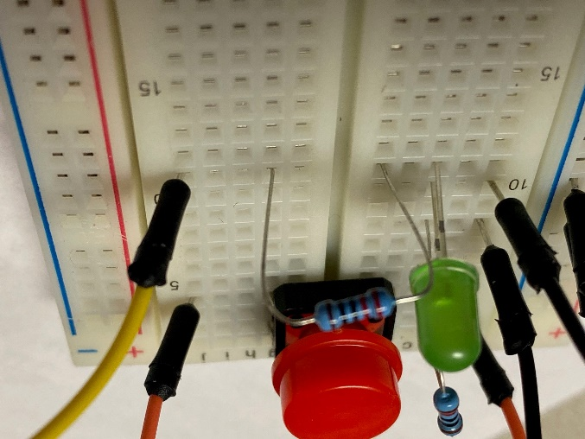

# Hardware: Add the other two lights

* Two more lights to go!
* We will need some more of the same components. Follow the new diagram to see where to connect these new lights. If you want an extra challenge. Try to connect the lights without looking at the diagram!

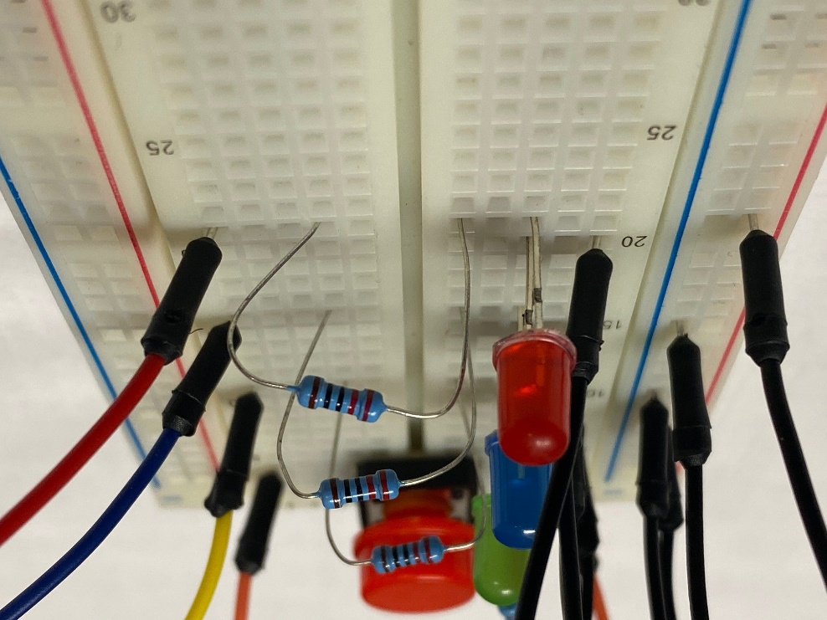

* This is the final diagram, double check that all your wires are connected in the right place!

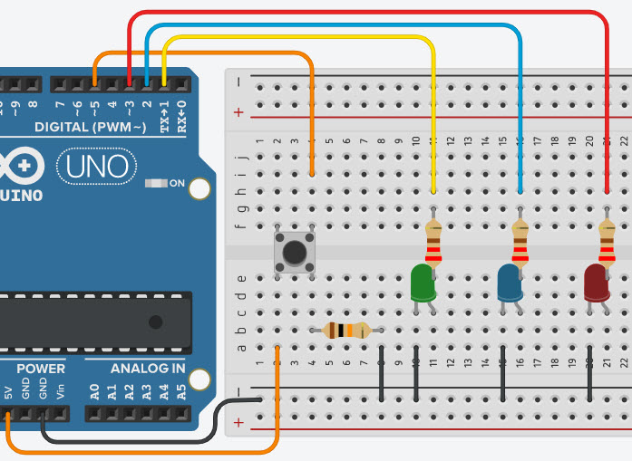

# Hardware: Power up the board

* Using the blue USB cable, connect your Arduino kit to your laptop. Open up the Arduino studio and hit execute.

# Test it out!

* Once you hit execute, you should see all of the LED lights on your Arduino light up, then they will change whenever you hit the button.
* If anything doesn’t work, don’t worry! Arduinos are very picky. Go back through the diagrams and double check that all the wires are connected where they should be. You can also ask your teacher for help.

# Software: make some changes

* Once you have tested your Arduino and you know everything works correctly, look at the code that you just uploaded. Any like with a **‘** in front of it is a comment. These lines don’t do anything to the Arduino but they help explain the code you are looking at.